ER DIAGRAM

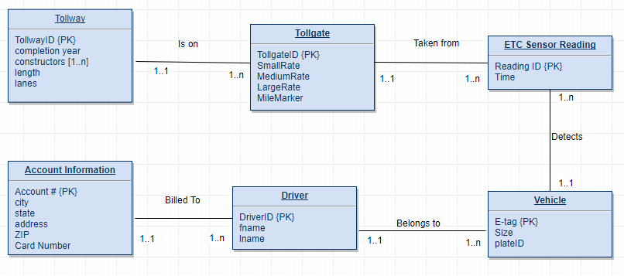

DATABASE SCHEMA

Tollway

|  |  |  |  |  |
| --- | --- | --- | --- | --- |
| TollwayID | Completion year | constructors | Miles | lanes |

Tollgate

|  |  |  |  |  |  |
| --- | --- | --- | --- | --- | --- |
| tollgateID | SmallRate | MediumRate | LargeRate | MileMarker | TollwID |

ETC Sensor Reading

|  |  |  |  |
| --- | --- | --- | --- |
| Reading ID | Time | TollID | E-Tag |

Vehicle

|  |  |  |  |
| --- | --- | --- | --- |
| E-tag | Size | PlateID | DriverID |

Driver

|  |  |  |  |
| --- | --- | --- | --- |
| LiscenseNum | fname | lname | Account # |

Account Information

|  |  |  |  |  |  |
| --- | --- | --- | --- | --- | --- |
| Account # | City | state | address | ZIP | Card # |